Lê Huỳnh Đức -21064491

1a)

#include <stdio.h>

#include <math.h>

using namespace std;

int main() {

int n, a[100], tang;

printf (" nhap so phan tu:");

scanf ("%d",&n);

for ( int i = 0 ; i < n; i++ ){

printf ("a[%d]=",i);

scanf("%d",&a[i]);

}

for ( int i = 0 ; i < n ; i++) {

printf ("%d",a[i]);

for ( int i= 0 ; i < n - 1 ; i++)

for ( int j = i + 1 ; j < n ; j++)

if ( a[i]> a[j]) {

tang = a[i];

a[i]=a[j];

a[j]= tang;

}

printf ("\n gia tri tang dan = ");

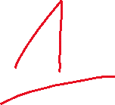

for ( i = 0 ; i < n ; i++)

printf ("%d",a[i]);

}

return 0;

}

1b)

#include <stdio.h>

#include <iostream>

#include <math.h>

int main() {

float n, giam ;

float a[100];

printf (" nhap so phan tu:");

scanf ("%f",&n);

printf ("\n ---- Nhap Mang ---- ");

for ( int i = 0 ; i < n; i++ ){

printf ("\n a[%d]=",i);

scanf("%f",&a[i]);

}

for ( int i = 0 ; i < n ; i++) {

printf ("%f",a[i]);

for ( int i= 0 ; i < n - 1 ; i++)

for ( int j = i + 1 ; j < n ; j++)



if ( a[i]< a[j]) {

giam = a[i];

a[i]=a[j];

a[j]= giam;

}

printf ("\n gia tri giam dan = ");

for ( int i = 0 ; i < n ; i++) {

printf ("%f",a[i]);

}

}

return 0;

}

1c tìm giá trị bé nhất

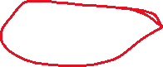

#include <stdio.h>



#include <math.h>

using namespace std;



int main() {

int n, a[100], min;

printf (" nhap so phan tu:");

scanf ("%d",&n);

for ( int i = 0 ; i < n; i++ ){

printf ("a[%d]=",i);

scanf("%d",&a[i]);

}

min = a[0];

for ( int i= 0 ; i < n; i++)

if (min > a[i]){

min = a[i];

printf ("\n gia tri be nhat la =%d ", min);

}

return 0;

}

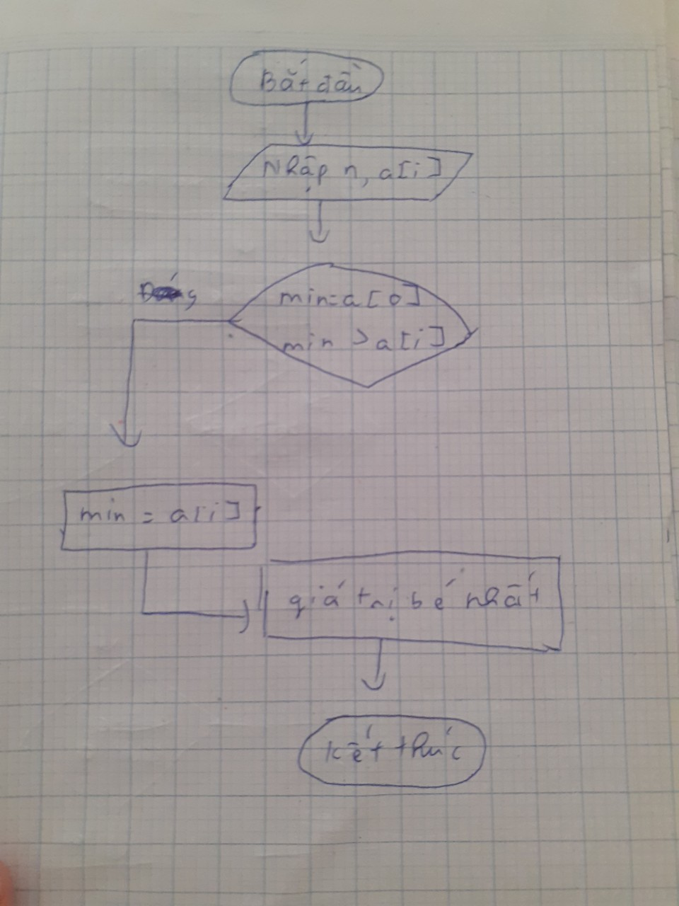

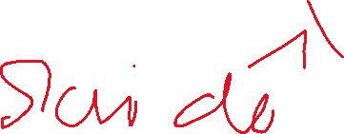

Tìm giá trị lớn nhất

#include <stdio.h>

#include <math.h>

using namespace std;

int main() {

float n, a[100], max;

printf (" nhap so phan tu:");

scanf ("%f",&n);

for ( int i = 0 ; i < n; i++ ){

printf ("a[%f]=",i);

scanf("%f",&a[i]);

}

max = a[0];

for ( int i= 0 ; i < n; i++)

if (max<a[i]){

max = a[i];

printf ("\n gia tri lon nhat la =%f ", max);

}

return 0;

}

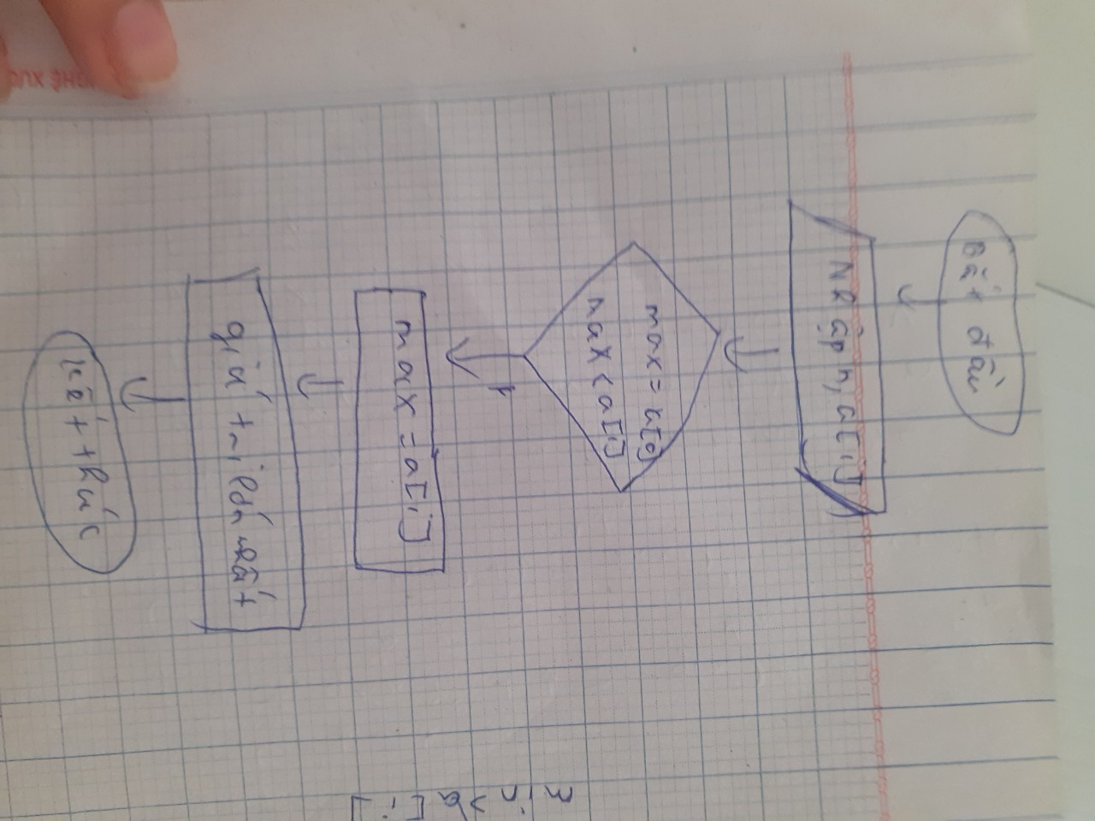

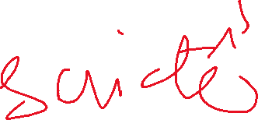

1d

#include <stdio.h>

#include <math.h>

using namespace std;

int main() {

float n, a[100], min;

float tich = 1 ;

printf (" nhap so phan tu:");

scanf ("%f",&n);

for ( int i = 0 ; i < n; i++ ){

printf ("a[%d]=",i);

scanf("%f",&a[i]);

}

for ( int i = 0 ; i < n ; i++) {

printf ("%f",a[i]);

tich = tich \* a[i];



if ( tich < 0 ) {

tich = tich \* -1;

} else if ( tich > 0) {

min = a[0];

for ( int i= 0 ; i < n; i++)

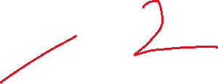

if (min > a[i]){

min = a[i];

}

printf (" \n tich cua mang la = %f ",tich);

printf ("\n gia tri be nhat la =%f", min);

}

}

return 0;

}

Câu 2 a

#include <stdio.h>

int main() {

int a[100][100];

int h , c;

printf ( " \n nhap so hang = ");

scanf (" %d",&h);

printf ( " \n nhap so cot = ");

scanf (" %d",&c);

// nhap so hang va cot

// nhap so can in ra trong hang

for ( int i = 0 ; i < h ; i++) {

// nhap so can in ra trong cot

for ( int j = 0 ; j < c ; j++) {

printf (" nhap a[%d][%d] = ", i , j);

scanf ("%d",&a[i][j]);

}

printf ("\n");

}

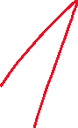

for ( int i = 0 ; i < h ; i++) {

for ( int j = 0 ; j < c ; j++) {

printf ("%2d", a[i][j]);

}

printf ("\n");

}

}

Câu 2 b



#include <stdio.h>

#define max 100

void nhapmt(int (\*a)[max][max], int \*h, int \*c)

{

printf("nhap so hang: ");

scanf("%d", h);

printf("nhap so cot: ");

scanf("%d", c);

for (int i = 0; i < \*h; i++)

{

for (int j = 0; j < \*c; j++)

{

printf("nhap so a[%d][%d]: ", i, j);

scanf("%d", &(\*a)[i][j]);

}

}

}

void xuatmt(int (\*a)[max][max], int \*h, int \*c)

{

for (int i = 0; i < \*h; i++)

{

for (int j = 0; j < \*c; j++)

{

printf("%d ", (\*a)[i][j]);

}

printf("\n");

}

}

int \*timsochandau(int (\*a)[max][max], int \*h, int \*c)

{

for (int i = 0; i < \*h; i++)

{

for (int j = 0; j < \*c; j++)

{



if ((\*a)[i][j] % 2 == 0)

return &(\*a)[i][j];

}

}

return 0;

}

int \*timsoledau(int (\*a)[max][max], int \*h, int \*c)

{

for (int i = 0; i < \*h; i++)

{

for (int j = 0; j < \*c; j++)

{

if ((\*a)[i][j] % 2 != 0)



return &(\*a)[i][j];

}

}

return 0;

}

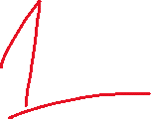

int main()

{

int a[max][max];

int h, c;

int i, j;

nhapmt(&a, &h, &c);

xuatmt(&a, &h, &c);

int \*scd = timsochandau(&a, &h, &c);

int \*sld = timsoledau(&a, &h, &c);

if (scd==0)

printf("So le dau tien trong ma tran la: %d ", \*sld);

else

printf("So chan dau tien trong ma tran la: %d ", \*scd);

return 0;

}

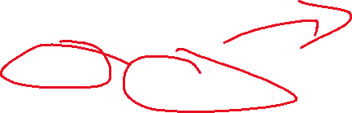

2c

#include <stdio.h>

int main() {

int a[2][2];

int h , c;

int sum = 0;

float d =0 ;

for ( int i = 0 ; i < 2 ; i++) {

for ( int j = 0 ; j < 2 ; j++) {

printf (" nhap a[%d][%d]=",i,j);

scanf ("%d",&a[i][j]);

}

printf ("\n");

}

for ( int i = 0 ; i < 2 ; i++) {

for ( int j = 0 ; j < 2 ; j++) {

sum = sum + a[i][j];

}

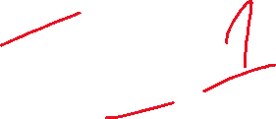

}

d = a[0][0] \* a[1][1]-a[0][1] \* a[1][0];

printf ( " tong ma tran la : %d",sum);

printf ( " dinh thuc ma tran la : %f",d);

return 0;

}